The Deems Job Loss Reaction Cycle™.
Developed By
Richard S Deems, PhD and Terri A Deems, PhD and Sandra Brownfield Deems, MKC

In an earlier career, Richard spent a good deal of time coaching people who had terminal illness or who had watched a loved one die. He became very familiar with the death and dying reactions of people, outlined and discussed in detail by Elizabeth Kubler-Ross. When Richard went through his own job loss he tried to apply the several stage Kubler-Ross paradigm to his own situation. It didn’t always match.
That began many years of researching what happens to people who have lost their jobs. As he talked with others, and kept in mind his own experience of job loss, Richard began to identify a six-stage process. His research indicates that everyone who loses a job goes through all the stages. Some take longer than others. Most get to Acceptance and Affirmation within a few weeks. A few, a very few, never move out of Shock and/or Disbelief or Anger and/or Resentment.

This is the Deems Job Loss Reaction Cycle™:
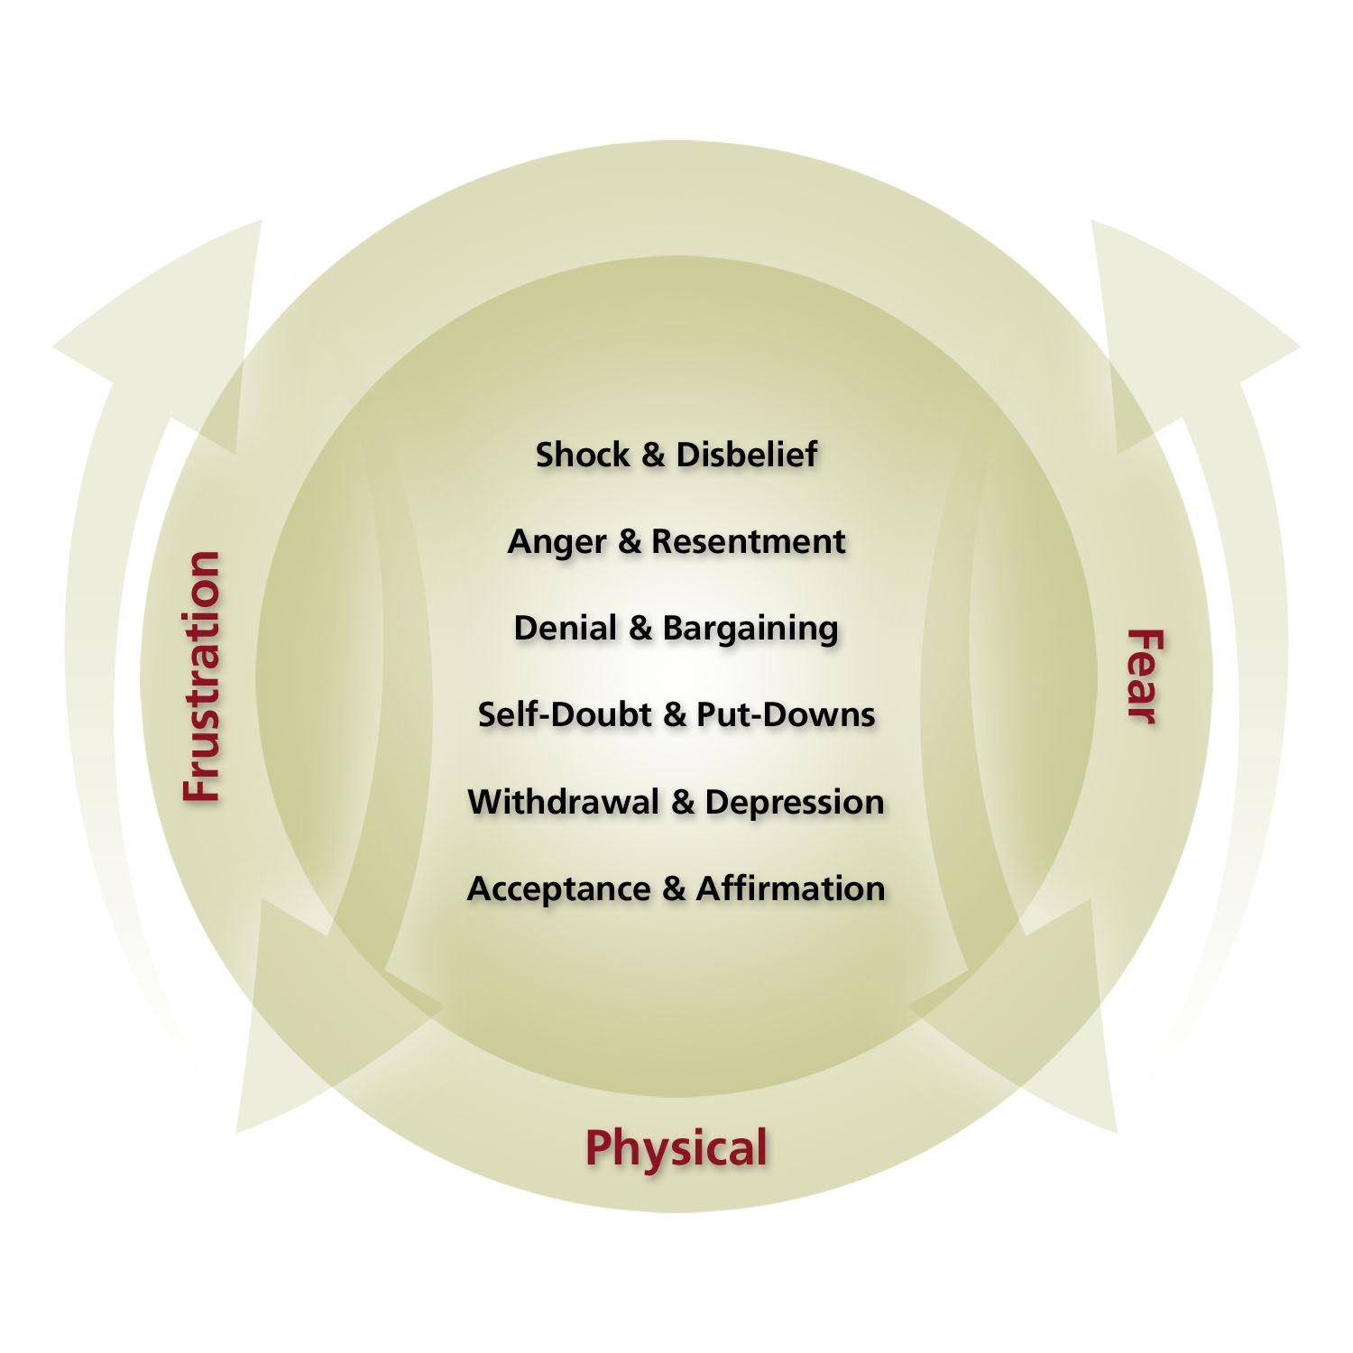

© Copyright 2006 by Richard S Deems

Decision Makers and the Cycle
Everyone goes through it. The decision makers go through it as they struggle with their decisions. First comes the shock of having to make the hard decisions. Then the anger that things aren’t working out the way they should. Followed closely by various forms of denial or bargaining, hoping that things will somehow turn around and it won’t be necessary. “Maybe if I work longer hours we won’t have to let people go.”
Then there’s the self-doubt and put-downs. Believing that a downsizing or termination is somehow the result of their own poor decisions. Or that “I must be a lousy person because of what I’m about to do to these people.” And there’s often withdrawal. Employees can usually read these signals and know when something is about to happen. The decision makers pull away, aren’t as accessible, don’t return phone calls or say Hi in the halls. Finally, decision makers acknowledge that it has to happen, it’s their responsibility, and let’s get on with it. Acceptance and, hopefully, Affirmation to do it right.
But it isn’t a nice and neat and linear process. Decision makers go back and forth between the various Cycle dimensions. They may get up in the morning ready to get at it, only to pull into the parking lot and see someone whose job will be eliminated in a few days and go straight to anger that this has to happen. Or maybe it’s the put-downs or depression.

People who lose their jobs go through the same process.
When we work with individuals or groups who have lost their jobs, we spend quite a bit of time reviewing and discussing this Cycle. It will be helpful for you to have at least a brief understanding of the phases people go through upon hearing that their job has been eliminated.
Shock and/or Disbelief. Even though employees may suspect a downsizing is about to take place, or an employee “knows I’m going to be fired,” there is still a time of shock and disbelief when a person actually hears the words, “Your job is being eliminated,” or “We will terminate your employment with ABC Corp.” Many people we’ve worked with describe this moment as being a surreal sense, like being in a dream. Very often, they stop hearing what is being said beyond this initial announcement. This is another reason why having it all written down in the summary letter is so important. They need to leave the meeting announcing their job elimination with something written so they can look at it again later.
For some this Shock lasts only a short time. Minutes, hours at most. One of the reasons why we urge decision makers to have the job transition specialists on site on the day of the announcement is so they can begin their work right after you make your announcement. After all, it’s pretty hard for people to stay in Disbelief if the job search specialists are talking to you about how to turn job-hunting into JobGetting™.
Anger and/or Resentment. Shock turns very quickly into anger. Anger can stay on as Resentment. Anger that this has happened, now. That their position was selected to be eliminated. Or their performance ended in firing. That managers made decisions last year or five years ago that somehow led to this moment. Most people see, quickly, that it’s self-defeating to stay in this phase, but some do anyway. The anger often gets directed to the organization’s decision makers. And usually the anger simply takes the form of words. Only very, very, occasionally does it turn to physical action. And then, in most cases, only when the angry-violent employee feels he or she or co-workers have not been treated fairly.
When job transition help, severance, and other assistance are provided to exiting employees, it is easier for them to move on from Anger or Resentment. Exiting employees may not like having to search for a new place to use their skills, but you’ve at least made it as easy as possible for them.
Denial and/or Bargaining. When Richard lost his job he spent several months bargaining with the person who let him go. Richard would work out a plan for his return, take it to Clive, and talk about it. He was always turned down. And he wasted six months trying to bargain his way back in.
Most exiting employees realize the termination is final. But a few might really deny that they have really lost their jobs and will attempt various forms of bargaining. Lower salary. Fewer perks. Longer hours. When that occurs, thank them and then encourage them to continue their job search. Exiting people need to move on, and sometimes you need to help remind them to do that.
Self-Doubt and/or Put-Downs. Even though the economy might have gone down the tubes, many downsized people start thinking the downsizing was a result of something they did. Or they simply begin to doubt what they have to contribute. Some little mental voice creeps in saying things like, “If you were really any good, they’d have found a way to keep you.” They put themselves down in terms of what they have contributed to the organization in the past and what they can contribute in the future. They think of how they’ve let their family down, or wonder if they can ever do anything right again.
Not rational. Not reality. But it happens.
When the transition specialists focus on peoples’ results, and what they’ve accomplished in previous jobs, it’s hard to put yourself down. The best job transition professionals are those who quickly get people to focus on their accomplishments, and not waste time in pity-parties.
Withdrawal and/or Depression. This phase of the process can be devastating. After all, it’s very easy for some to sleep in late, look at the want ads in their pajamas while they drink coffee, and not bother to get dressed as if going to work. The longer it goes on, the more a person withdraws. Depression can set in.
When transition assistance is provided it’s more difficult for people to withdraw. They have to go to the meetings. There’s a schedule to keep each day, making it necessary to get up and get dressed. And the transition specialists can keep track of those who may be having a more difficult time. Either extra assistance can be provided, or they can be guided to the EAP when appropriate, or urged to see their own physician.
One group WorkLife Design’s staff assisted decided on their own that Withdrawal was not going to be tolerated. Each weekend they would meet to share notes, socialize, and encourage each other. Pessimistic attitudes (“I’ll never find another job I like”) were not tolerated. They helped each other.
And yes, they all got new jobs within 90 days.
Acceptance and Affirmation. For well over 95% of the people we’ve worked with, Acceptance and Affirmation becomes a reality within weeks. A few take months. And only a very small number never regain it.
It is acceptance that they went through a major job change.
And affirmation that they have much to contribute – that this can be a tremendous step forward for them.
In our own approach to job transition we urge people to stop and evaluate their strengths, values, and what they want from a job. After all, we remind people, this can be a great time to stop and figure out their ideal job. When people take this track we show them how to identify what they do best and what they most enjoy doing – and then how to get paid for doing it.
When people focus on strengths and the results of their work Acceptance and Affirmation comes quickly!

Fear, Frustration, and Physical.
People go through this Cycle surrounded by a sense of Fear, Frustration, and Physical. Fear that it will take a long time to find another job. Fear that bills won’t get paid. Fear that friends won’t call. Fear that the kids won’t love me.
Frustration has to do with taking time to learn a whole new set of skills. The Deems JobGetting Skills™ have to be learned and practiced. They aren’t inherent within a person. And the routine has now been changed. Frustration.
And Physical. There is considerable research that shows people get more colds, have more stomach aches, and more head aches, as a result of stress. And losing one’s job is full of stress. So it is common for people to have more physical ailments the first few weeks after job loss. Stress can also lower a person’s natural immune system, making them more susceptible to the usual bugs and colds and flu.
Do all you can do to show people how to get to Acceptance and Affirmation quickly!

In the Deems Job Loss Reaction Cycle™ you’ll notice that the arrows go both up and down. That’s because people going through this Cycle don’t do it in a neat, sequential way. They may start off in Shock & Disbelief and then jump to Acceptance & Affirmation. Or maybe they’ll go to Anger & Resentment, and back to Acceptance & Affirmation, and then to Self-Doubt & Put-Downs and back to Acceptance & Affirmation.
It’s an up and down and back and forth reaction until the person finally settles in with Acceptance & Affirmation. There is not one neat way that everyone goes through the job loss experience. Maybe that’s why some find it so exhausting.

Adapted from The Manager’s Pocket Guide® to Downsizing with Confidence (HRD Press, 2008) by Richard S Deems, PhD and his daughter, Terri A Deems, PhD, and How To Fire Your Friends, by Richard S Deems, to be released in Second Edition in 2009.

This article is © Copyright 2008 by Richard S Deems, PhD

